**Finding the best location for a Night-Club in Amsterdam**

Hardeep Dhaliwal

June 15, 2021

**1. Introduction**

**1.1 Goal**

This project aids to find the optimal location for a Night-Club in Amsterdam to aid with tourism and generating traffic into Amsterdam as covid-19 restrictions loosen around the world. Through the usage of python, foursquare API, libraries, and data visualization techniques an optimal neighborhood location in Amsterdam will be selected.

**1.2 Background**

As the vaccine rollout accelerates around the world and more countries are opening borders and allowing tourists to visit the nightlife scene will only grow and have the potential to generate large amounts of revenue for businesses looking to take advantage. In choosing the city for this new Night-Club, Amsterdam was selected based on its history of being one of the greatest cities in the world to party in. According to [Thrillophilia](https://www.thrillophilia.com/blog/greatest-cities-in-the-world-to-party/" \t "_blank) Amsterdam is ranked 3rd in the world for cities to party in, making it an excellent city to host this new Night-Club. In addition to reputation, looking at the data of inbound tourists in the Netherlands, according to [statista](https://www.statista.com/statistics/658819/inbound-tourism-forecast-in-the-netherlands/" \t "_blank) the amount of tourists coming into the Netherlands from 2014 to 2019 was steadily increasing and peaked at **20.1 million** in 2019. The value dropped with the restrictions caused from the covid-19 pandemic to 7 million, however, as vaccines get distributed and restrictions are lifted, this value will rebound and create demand for tourist attractions like a Night-Club.

Now, with the problem and background defined, the data and parameters that are going to be used for picking the neighborhood to host this Night-Club must be defined as well.

According to [superevent](https://superevent.com/blog/13-important-things-to-consider-when-choosing-your-event-venue/" \t "_blank) important factors to consider when choosing an event venue include, parking and accessibility. Therefore, the location must have large enough parking spots within a given radius and be easily accessible by as many modes of transportation, including public transport like buses, metro/subway stations, train stations, etc.

**2. Data Description**

First and foremost, to select the optimal neighborhood that would host this new Night-Club, data about the different neighborhoods in Amsterdam is required. To achieve this, the website [ClairCity](https://claircitydata.cbs.nl/dataset/districts-and-neighbourhoods-amsterdam" \t "_blank) provides a dataset on the districts and neighborhoods in Amsterdam. Next, the parking lots location in Amsterdam can be found via the [FourSquare API](https://developer.foursquare.com/docs/build-with-foursquare/categories/" \t "_blank). The final dataset we need can also be found via the FourSquare API and it includes the public transportation list, which includes Bus, Metro, Light Rail, and Train stations and their respective geolocations. With these datasets the locations of all neighborhoods and be established and clustering techniques can be used to find the optimal location which has many parking spots and is accessible by a variety of public transportation options.

**3. Methodology**

**3.1 Data Processing**

The [ClairCity](https://claircitydata.cbs.nl/dataset/districts-and-neighbourhoods-amsterdam) data containing the different boroughs, towns, and neighborhoods of Amsterdam was imported into a pandas data frame and the unnecessary columns were dropped leaving only the Neighborhoods, City, Longitude and Latitude columns. Next, two additional columns were added, these include the distance of parking lots to that neighborhood and the amount of public transportation stops within a given a radius to that neighborhood. These two additional columns were left blank as they would be filled in later on.

Next, the data frame of the neighborhoods was visualized via the Folium library and the output can be seen in figure 1.

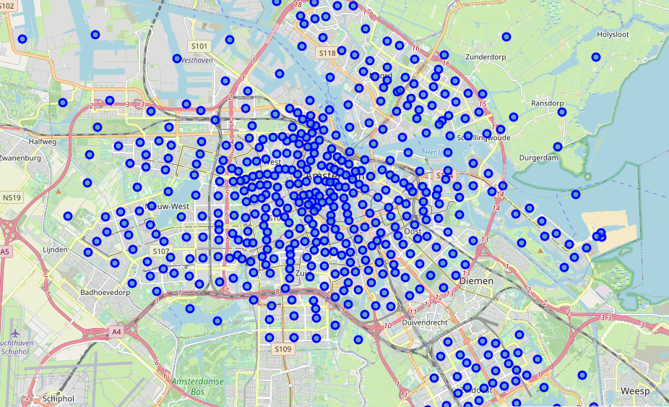Figure 1: Neighborhoods in Amsterdam, noted by blue markers, visualized via Folium

Now, the datasets for the parking lots and public transportation stops can be imported. To achieve this, the FourSquare API must be utilized. Using the required information and the categoryID for parking lots (4c38df4de52ce0d596b336e1), the JSON file can be imported and read. This file is very large and contains more information than we need. Therefore, by utilizing the get\_category\_type function and passing the parking lots category through this we can assemble a data frame with the parking lots in Amsterdam, as shown in table 1.

Table 1: 5 Parking spots in Amsterdam with their respective Latitude and Longitude

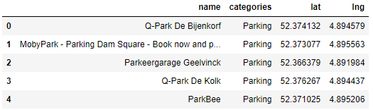

Next, the public transportation spots can be found and imported into a data frame, repeating a similar process to creating the parking spots data frame. However, first we must define what public transportation spots we are interested in. **Looking at the**[FourSquare](https://developer.foursquare.com/docs/build-with-foursquare/categories/" \t "_blank)**site, the category ID's for the different public transportation options can be found.**

* Light Rail Station categoryId is "4bf58dd8d48988d1fc931735"
* Metro Station categoryId is "4bf58dd8d48988d1fd931735"
* Tram Station categoryId is "52f2ab2ebcbc57f1066b8b51"
* Bus Station categoryId is "4bf58dd8d48988d1fe931735"

Since we are limited to the amount of responses we can receive from the FourSquare API, a *for loop* can be used to send the 4 different categoryID's as sub-categoryID's. This for loop updates the information into a dataframe called df\_trans and at the end we append each iteration to the final dataframe called df\_trans\_total. The final outcome of this process can be seen in table 2.

Table 2: 5 Public Transportation stops, of different categories, in Amsterdam with their respective Latitude and Longitude

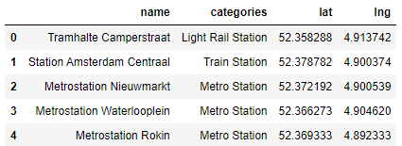

**3.2 Data Analysis**

Now that all the required data has been imported into their respective data frames, the analysis can begin to determine which neighborhood in Amsterdam would be the optimal host for a Night-Club based on its vicinity to as many parking spots and public transportation stops. To begin, the average distance between all parking lots and neighborhoods can be found and added to the empty column CarPark\_dis that was left empty previously. The data frame should now resemble table 3.

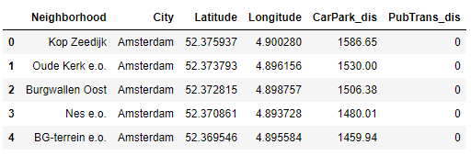Table 3: Neighborhoods in Amsterdam with their respective Latitude, Longitude, and average distance to every parking lot location

Then, a for loop is used to calculate the number of Light Rail/Metro/Train/Tram/Bus Stations within a 1000m radius for each neighborhood and these results are put into the PubTrans\_dis column. The data frame should now resemble table 4.

Table 4: Neighborhoods in Amsterdam with their respective Latitude, Longitude, average parking lot distance and total number of public transportation stops within a 1000m radius

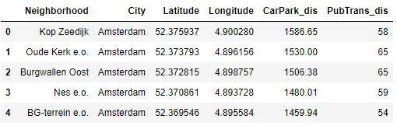

To help better define which neighborhood has the minimal distance to the parking lots in Amsterdam and the maximum number of public transportation stops within a 1000m radius, the values from these two columns must be normalized. To do this, the maximum value from each column is subtracted from the present value then divided by the max so that the new value is from 0-1. The values are added to 2 new columns containing the normalized values from CarPark\_dis and PubTrans\_dis. The final table should resemble table 5.

Table 5: Neighborhoods in Amsterdam with normalized values from the average distance to all parking lots in Amsterdam and normalized values of number of public transportation stops within a 1000m radius

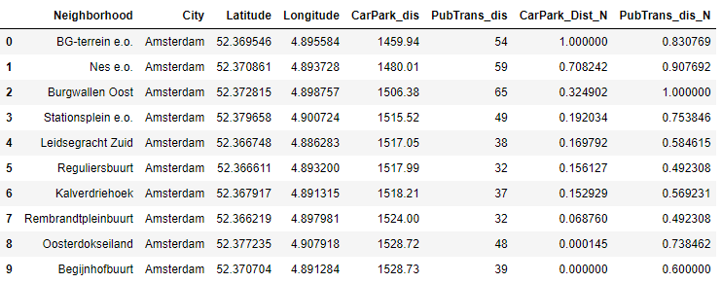

**4.0 Results**

Taking table 5, the top 10 neighborhoods can be plotted with the normalized values from the CarPark\_Dist\_N and PubTrans\_dis\_N being plotted on a bar graph. The graph should resemble figure 2.

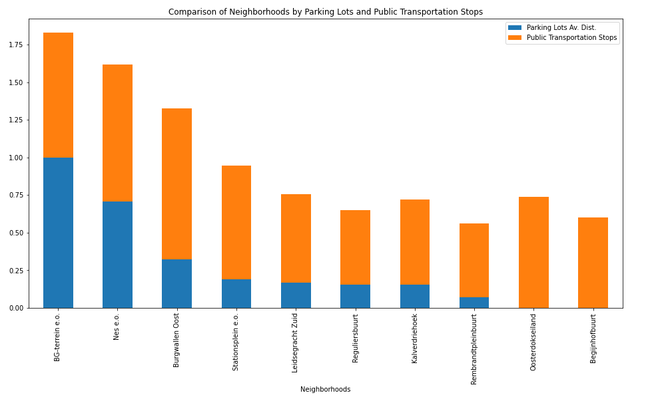

Figure 2: Average parking lots distance and public transportation stops for 10 neighborhoods in Amsterdam

From analysing this graph, it can be noted that BG-terrein e.o. would be the optimal location for a Night-Club as it has the highest number of parking lots and public transportation stops which are accessible for a given radius. To further analyse this location, BG-terrein e.o. has 17 parking lots in a 500m radius and 54 public transportation stops in a 1000m radius. The neighborhood location and some of the parking lots and public transportation stops can be seen plotted on a map in figure 3.

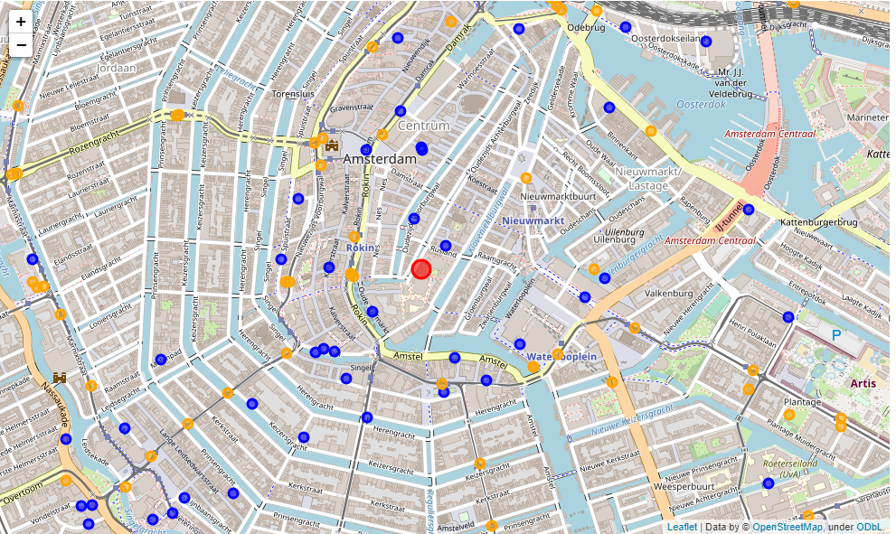

Figure 3: BG-terrein e.o, noted in red, surrounded by parking lots in blue and public transportation stops in orange

**5.0 Discussion**

The optimal location found through this analysis is based on the number of parking lots and public transportation stops found in a local vicinity. Therefore, the location should only be considered for these aspects and doesn’t encompass the various additional factors that should be considered for opening a Night-Club location. Various additional factors can be found in [superevent](https://superevent.com/blog/13-important-things-to-consider-when-choosing-your-event-venue/) and include the cost of each location, the capacity, size, and layout. For a comprehensive and detailed image of a primary location for a Night-Club these aspects should be considered as well. Therefore, the final location BG-terrein e.o., must be analysed further based on additional parameters for the Night-Club to be successful, however, from this report, the location could be a good suggestion for a starting location for investors to look into.

**6.0 Conclusion**

In conclusion, this project encompassed various data analysis techniques using python scripts, libraries, visualization, and API. Through the analysis of the three different datasets utilized, it was found the optimal location for a Night-Club in Amsterdam would be BG-terrein e.o. This neighborhood was selected based on its vicinity and accessibility to parking lots and various public transportation options. For future analysis, further parameters must be considered to ensure the Night-Club location is truly optimal and successful. Therefore, this project can be used as a starting point or part of an analysis technique to determine a successful Night-Club location.